

**Admission Chance Prediction...**

A Project/Thesis Submitted in Partial

fulfillment for the requirement of the

Degree of

Bachelor of Science

in

Computer Science and Engineering

**Supervised by…**.

**Dr. Mohammad Amanul Islam**  
Lecturer  
Department of Computer Science and Engineering   
Shanto - Mariam University of Creative Technology

**Submitted by…**.

**Md. Mubarak Hossain**  
 ID :- **201076001**  
 Semester :- 11th  
 Batch :- 17th

March-2024

to the   
 Department of Computer Science and Engineering   
 Shanto-Mariam University of Creative Technology

**Acknowledgement**

This thesis has been submitted to the Department of Computer Science and Engineering of Shanto-Mariam University of Creative Technology (SMUCT), Dhaka, Bangladesh, for the partial fulfillment of the requirements for the degree of B.Sc. in Computer Science and Engineering. Project title regards to "Admission Chance Prediction ".

First and foremost, we offer our sincere gratitude and indebtedness to our project supervisor, **Dr. Mohammad Amanul Islam**, Lecturer, Department of Computer Science and Engineering who has supported us throughout our project with his patience and knowledge. We shall ever remain grateful to him for his valuable guidance, advice, encouragement, cordial and amiable contribution to our project.

We wish to thank once again **Sazzad Hossain Bhuiyan** as the head of the Department of Computer Science and Engineering for his support and encouragement and also for providing all kind of laboratory facilities.

We would like to express our deep gratitude to the administration of Shanto-Mariam University of Creative Technology for providing a self-sufficient Under Graduate (UG) lab.

Finally, we want to thank the most important and the closest persons of our life and our parents for giving a big support to us.

**Md. Mubarak Hossain**  
ID :- **201076001**  
Semester :- 11th  
Batch :- 17th

March-2024  
SMUCT, Dhaka, Bangladesh

**CERTIFICATE**

This is to certify that the project entitled “**Admission Chance Prediction** " by Md. Mubarak Hossain (Roll No. 201076001) has been carried out under my direct supervision. To the best of my knowledge, this project is an original one and has not been submitted anywhere for any degree or diploma.

Project Teacher:

.......................................

**Dr. Mohammad Amanul Islam**   
Lecturer  
Department of Computer Science and Engineering   
Shanto-Mariam University of Creative Technology

**Abstract**

Predicting admission chances for academic programs or institutions plays a vital role in guiding prospective students through the application process. This study aims to develop a predictive model for admission chances using machine learning techniques. The model leverages a dataset comprising various factors such as academic performance, standardized test scores, extracurricular activities, and demographic information. Feature engineering techniques are employed to extract meaningful insights from the dataset, followed by the application of regression algorithms to predict admission probabilities. Additionally, techniques such as cross-validation and hyperparameter tuning are utilized to enhance model performance and generalization. The proposed model demonstrates promising results in accurately predicting admission chances, thus providing valuable insights for both applicants and admissions committees in making informed decisions.

**Contents**

Acknowledgement ………………………………………………………………………… ii  
Certificate …………………………………………………………………………iii   
Declaration …………………………………………………………………………iv   
Abstract ………………………………………………………………………… v

**Chapter 1**

Introduction ………………………………………………………………………… 1.0

Motivation …………………………………………………………………………1.1

Literature Review …………………………………………………………………………1.2

Objective of the Project …………………………………………………………………………1.3

project Outline …………………………………………………………………………1.4

Data Collection …………………………………………………………………………1.5

Authentication …………………………………………………………………………1.6

Front-End …………………………………………………………………………1.7

Back-End Services …………………………………………………………………………1.8

**Chapter 2**

Dataset …………………………………………………………………………2.1

Exploratory Data Analysis ………………………………………………………………………… 2.2

Data Visualization …………………………………………………………………………2.3

The user interface created …………………………………………………………………………2.4

Output ………………………………………………………………………… 2.5

**Chapter 1**

**1.0 Introduction**

In the competitive landscape of higher education, securing admission to prestigious academic programs or institutions is a significant milestone for aspiring students. However, the admission process often involves numerous factors that can influence the likelihood of acceptance, making it complex and sometimes opaque. As such, there is a growing interest in developing predictive models that can estimate an individual's chances of admission based on various quantitative and qualitative factors.The purpose of this study is to explore the use of machine learning techniques to predict admission chances accurately. By leveraging historical data on admissions and applicant profiles, we aim to develop a model that can provide valuable insights for both prospective students and admissions committees. This predictive model holds the potential to streamline the application process, empower applicants with realistic expectations, and assist institutions in optimizing their selection criteria.In this introduction, we will outline the motivation behind admission chance prediction, discuss the significance of such models, and provide an overview of the methodology employed in this study. Additionally, we will highlight the potential implications and benefits of accurate admission chance prediction for various stakeholders involved in the higher education ecosystem.

* 1. **Motivation:-**

The motivation behind admission chance prediction is to empower applicants with insights into their likelihood of acceptance, optimize resource allocation for both applicants and institutions, promote transparency and fairness in the admissions process, support data-driven decision-making for admissions committees, and facilitate continuous improvement of admissions processes over time.

**1.2 Literature Review:-**

The literature on admission chance prediction encompasses a variety of approaches and methodologies, reflecting the interdisciplinary nature of the field. Several studies have focused on utilizing machine learning techniques, such as regression algorithms, decision trees, and neural networks, to predict admission probabilities based on applicant profiles and historical admissions data.

One prominent area of research involves feature selection and engineering, where studies explore the most relevant factors influencing admission decisions. Academic performance indicators, standardized test scores, letters of recommendation, personal statements, and extracurricular activities are among the commonly investigated features. Additionally, demographic factors such as gender, ethnicity, and socioeconomic background have been examined for their impact on admission chances and potential biases.Several studies have also investigated the performance of different machine learning algorithms in predicting admission probabilities. Comparisons between regression-based models, ensemble methods, and deep learning architectures have been conducted to evaluate their accuracy, robustness, and computational efficiency. Furthermore, techniques such as cross-validation, hyperparameter tuning, and model interpretation have been employed to enhance the reliability and interpretability of predictive models.Beyond technical aspects, the literature also addresses broader implications and considerations associated with admission chance prediction. Ethical concerns related to fairness, bias, and privacy are actively discussed, highlighting the importance of developing transparent and accountable predictive models. Additionally, studies explore the potential impact of predictive modeling on educational equity, access, and diversity, emphasizing the need for inclusive admissions practices and policies.Overall, the literature on admission chance prediction provides valuable insights into the development, evaluation, and application of predictive models in the context of higher education admissions. By synthesizing findings from various studies, researchers aim to advance our understanding of admission processes, improve decision-making practices, and promote equity and fairness in educational opportunities.

**1.3 Objective of the Project:**-

The main objective of this paper is to implement and compare various supervised predictive analysis techniques using a labeled dataset from real applications to the University of UCLA. Regression, classification, and Ensemble methods will be used to predict and evaluate the dataset, which focuses on the academic performance of applicants during their undergraduate years. The comparison of models will be based on metrics like the coefficient of determination, precision, and accuracy. While all methods yielded accurate results, some approaches showed more promise than others. These predictions have the potential to expedite the admission process significantly.

**1.4 project Outline:-**

* Creating a new Flutter application
* Connecting to
* Dataset

**1.5 Data Collection**

<https://www.kaggle.com/datasets/mdrehanali/admission-data>

**1.6 Authentication**

* GRE Score
* TOEFL Score
* University Rating
* SOP
* LOR
* CGPA
* Research

**1.7 Front-End**

* Input Guide
* Mobile Layout Screen
* Searching option

**1.8 Back-End Services**

………………………  
………………………  
………………………

Chapter 2

**2.0 PROPOSED METHODOLOGY**

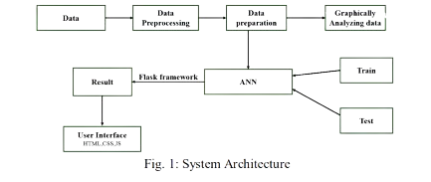

**2.1 Dataset**

The dataset named ‘admission.csv’ is taken from Kaggle which consists of 500 records with 7 features and one target variable. The 7 features include ‘GRE Score’, ‘TOEFL’, ‘University Rating’, ‘LOR’, ‘SOP’, ‘CGPA’, ‘Research’ and includes ‘Serial No.’ also and the target variable is the ‘Chance of Admit’.

**2.2 Exploratory Data Analysis**

In this step, the dataset is checked for missing values and found that it does not have any null values and the column ‘Serial No.’ is dropped since it is not useful for prediction.

**2.3 Data Visualization**

Here the features are visualized using histograms and scatterplot matrix which helps in detecting outliers (found that there are no outliers), for understanding the pairwise relationships between features and also finding the correlation between the features is visualized using heatmap.

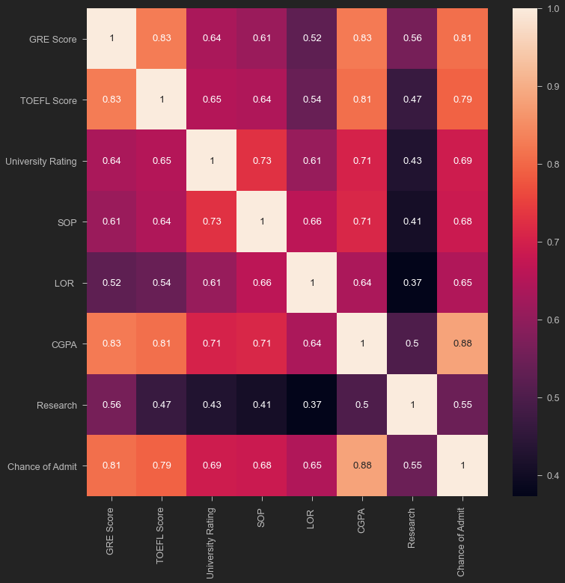

**2.4 The user interface created**

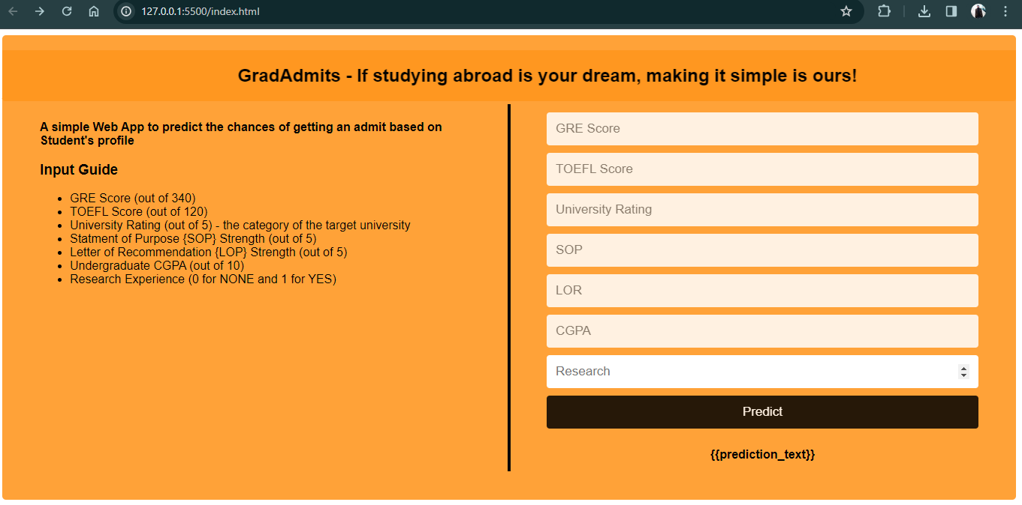

**2.5 Output when the user enters different values of input**

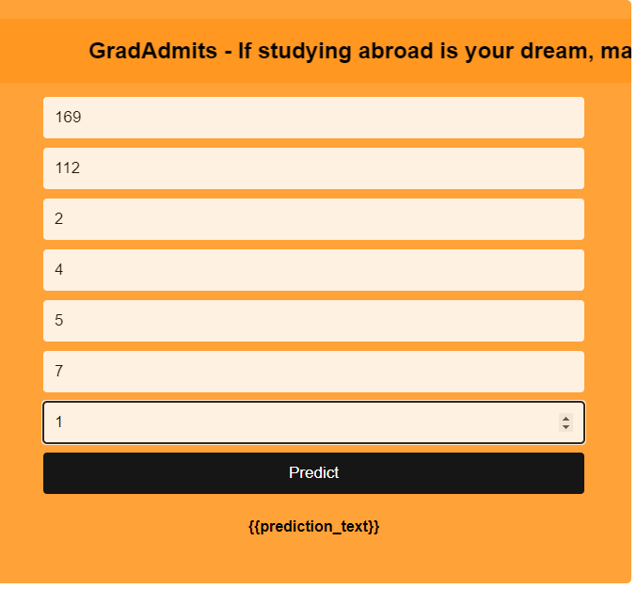

**CONCLUSION**

In this project, we predicted the chance of admit of a candidate i.e., the model can estimate the likelihood of admission based on various attributes like exam scores and personal statements with an accuracy of 94% and a low value of Mean Square Error. In future, the project can be extended by incorporating additional features such as internship details, work experience, or other relevant parameters that may influence admission decisions. Furthermore, the model's performance can be further improved by exploring advanced neural network architectures or implementing ensemble techniques.

**REFERENCES**

[1] Zain Bitar , Amjed Al-Mousa (2020), "Prediction of Graduate Admission using Mutiple Supervised Machine Learning Models, 2020 Southeast Con. IEEE".

[2] Sharan Kumar, Paratala Rajagopal, June 2020, "Predicting Student University Admission using Logistic Regression, European Journal of Computer Science and Information Technology".

[3] Mohan S Acharya, Dec 30, 2019, “A Comparison of Regression Models for Prediction of Graduate Admissions, IEEE International Conference on Computational Intelligence in Data Science 2019”

[4] Sravani Gorusu, Harsha Vardhini Eluru, "Machine Learning Model for Prediction of Post Graduate Admissions, Journal of Emerging Technologies and Innovative Research-2021".

[5] Janani P, Hema Priya V, Monisha Priya S, "Prediction of MS Graduate Admissions using Decision Tree Algorithm, International Journal of Science and Research 2018".